DC MOTOR DRIVES

**Four Quadrant Operations of DC Motor:**

**A four-quadrant or multiple-quadrant operation is required in industrial as well as commercial applications. These applications require both driving and braking, i.e., motoring and generating capability.**

**Some of these applications include electric traction systems, cranes and lifts, cable laying winders, and engine test loading systems.**

**he different quadrant operations drive the motor with normal as well as reversal of both voltage and currents so as to run as well as to break the motor either in forward or reverse directions.**

**Let us discuss these 4-quadrant operations in brief.**

**A DC motor may operate in one or more modes (or quadrant) in variable speed applications. The major advantage of using DC motor is that the ease of its control.**

**The speed of the DC motor is controlled by applying a variable DC input for below rated speed control. For above rated speeds, the motor is controlled by applying variable current through its field winding.**

**For reversing the direction of rotation, either polarity of the supply voltage (which is applied to armature terminals) or the direction of field current has to be changed.**

**By using DC motors, it is possible to obtain smooth speed control over a wide range in clockwise as well as anti-clockwise directions.**

**The torque of a DC motor is proportional to the armature current which in turn depends on the difference between back emf and applied voltage.**

**Therefore, it is possible to make the motor to develop positive or negative torque simply by controlling the applied voltage to a greater or lesser than the back emf.**

**Thus an armature controlled DC machine is inherently capable of operating different modes or quadrants, generally it is known as four-quadrant operation of a motor.**

**In multi-quadrant operation or four quadrant operation, motor accelerates or decelerates depending on whether motor torque is lesser or greater than load torque.**

**During motor acceleration, it should supply not only the load torque, but an additional component of load current to overcome the inertia.**

**Motor positive torque produces the acceleration in forward direction. In this, the motor speed is positive when the motor is rotating in forward direction.**

**During motor deceleration, the resultant or dynamic torque has a negative sign. This torque assists with motor developed torque and maintains the motion by extracting the energy from stored energy.**

**Hence the motor torque is considered as negative if it produces deceleration.A motor can be controlled in such a way that it operates in two cases; motor action and braking action.**

**Motor action converts the electric energy into mechanical energy and it produces forward motion, hence it called as motoring action, whereas braking action converts mechanical energy to electrical energy which gives forward braking motion, it is termed as generator.**

**Similarly, these two actions are performed in case motor operating in reverse direction, i.e., (reverse motoring and reverse braking actions).  
[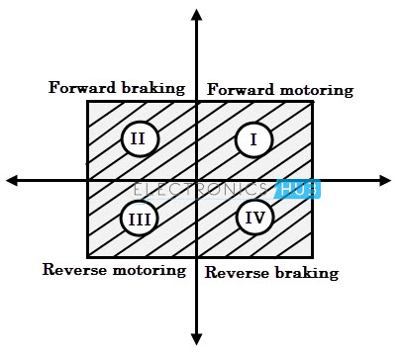](https://www.electronicshub.org/wp-content/uploads/2015/12/Speed-torque-characteristics-of-four-quadrant-operations.jpg)**

### Four Quadrant Operation of a DC Motor

**In a separately excited DC motor, the steady state speed is controlled at any desired speed by applying the appropriate magnitude of voltage, also in either direction simply by giving appropriate polarity of the voltage.**

**The torque of the motor is directly proportional to the armature current, which in turn depends on the difference between the applied voltage V and back emf, E, i.e.,**

**I = (V – E) / R**

**Therefore, it is possible to develop positive or negative torque by controlling voltage, which is less than or more than the back emf. Hence the separately excited DC motor inherently exhibit four quadrant operation.**

**The below figure shows four quadrant operation of a separately excited DC motor in which a dot symbol on one of motor terminals indicates the sign of the torque.**

**The machine produces a positive torque, if current flows into the dot. Similarly the torque is negative, if current flows out of the dot. Also, the relative magnitudes of voltage and back emf are shown in figure. These four quadrants are explained below.**

#### [four quadrant operations of a DC motor](https://www.electronicshub.org/wp-content/uploads/2015/12/four-quadrant-operations-of-a-DC-motor.jpg) Forward Motoring

**In this mode of operation, the applied voltage is positive and greater than the back emf of the motor and therefore a positive current flow into the motor.**

**Since both current and voltage are positive, the power becomes positive. And also the speed and torque are also positive in this quadrant. Therefore the motor rotates in forward direction.**

#### [first quadrant operation](https://www.electronicshub.org/wp-content/uploads/2015/12/first-quadrant-operation.jpg)Forward Braking

**In this mode of operation, the motor runs in forward direction and the induced emf continues to be positive. But the supplied voltage is suddenly reduced to a value which is less than the back emf.**

**Hence the current (there by torque) will reverse direction. This negative torque reverses the direction of energy flow.**

**[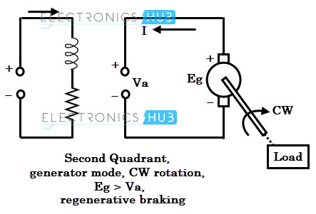](https://www.electronicshub.org/wp-content/uploads/2015/12/second-quadrant-operation.jpg)**

**Since the load torque and motor torque are in opposite direction, the combined effect will cause to reduce the speed of the motor and hence back emf (motor emf is directly proportional to the speed) falls again below the applied voltage value.**

**Hence, both current and voltage become positive and the motor settle down to first quadrant again. The process by which the mechanical energy of the motor is returned to the supply is called as regenerative braking.**

**This quadrant operation is the example of regenerative braking.**

#### Reverse Motoring

**This is the third quadrant operation of the motor in which both motor voltage and current are negative. Thus the power is positive, i.e., the power is supplied from source to load.**

**Due to the reverse polarity of the supply, the motor starts rotating in a counterclockwise direction (or reverse to normal operation).**

**[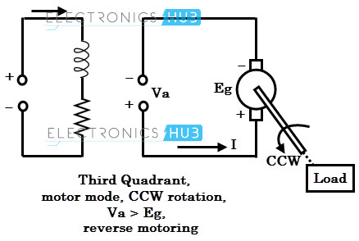](https://www.electronicshub.org/wp-content/uploads/2015/12/third-quadrant-operation.jpg)**

**The operation of this quadrant is similar to the first quadrant, but only difference is the direction of rotation. The magnitude of voltage to the motor decides the appropriate speed in reverse direction.**

#### Reverse Regenerative Braking

**This is the quadrant-4 mode of operation in which motor voltage is still negative and its armature current is positive.**

**This mode of operation is similar to the second quadrant operation and once again the regeneration occurs whenever the back emf is more than the negative supply voltage.**

**Hence the torque will be positive which opposes the load torque, thus the speed of the motor will be reduced during reverse operation of the motor.  
[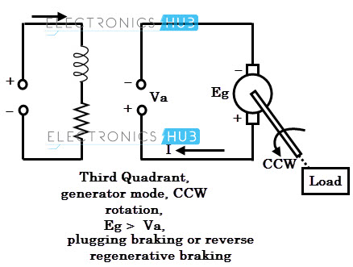](https://www.electronicshub.org/wp-content/uploads/2015/12/fourth-quadrant-operation.jpg)‘  
This mode of operation is mostly used for plugging in order to stop the motor rapidly. During plugging, the armature terminals are suddenly reversed, which causes the back emf to force an armature current to flow in reverse direction.**

**Now the effective voltage across the motor becomes 2V (as V+ Eb). A braking resistor in series with the motor has to be connected to limit this current.**

**Braking by plugging gives greater torque and more rapid stop, but the current drawn from the supply and energy stored in mechanical parts must be dissipated in resistance.**

### Applications of Four-quadrant Operation

* [**Electric traction system**](https://www.electronicshub.org/electric-traction-system/)
* **Battery operated vehicles**
* **Lifts and cranes**
* **Engine test loading systems**
* **Spindle and tool drives in machine tools**
* **Auxiliary drives in robotic systems**
* **Position control systems**

### Braking of DC Motors

**Braking is a very important operation for DC motor drives. The need of decreasing the speed of a motor or stopping it totally may arise at any moment, that’s when braking is applied. braking of DC motors is basically developing a negative torque while the motor works as generator and as a result the motion of the motor is opposed. There are mainly three types of braking of DC motors :**

1. **Regenerative braking**
2. **Dynamic or rheostat braking**
3. **Plugging or reverse voltage braking.**

**Regenerative braking takes place when the generated energy is supplied to the source, or we can show this via this equation : E > V and negative Ia.. 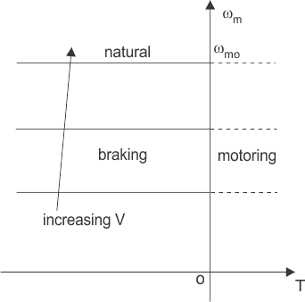As the field flux cannot be increased beyond a rated value, so regenerative braking is possible only when the speed of motor is higher than the rated value. The speed torque characteristics is shown in the graph above. When regenerative braking occurs, the terminal voltage rises and as a result the source is relieved from supplying this amount of power. This is the reason why loads are connected across the circuit. So, it is clear that regenerative braking should be used only when there are enough loads to absorb the regenerative power. Dynamic Braking is another type of braking of DC motor drives where the rotation of the armature itself causes the braking. This method is also a widely used DC motor drive system. When braking is desired, then the armature of the motor is disconnected from the source and a series resistance is introduced across the armature. Then the motor acts as a generator and current flows in the opposite direction which indicates that the field connection is reversed. The diagram for separately excited and** [**series DC motor**](https://www.electrical4u.com/series-wound-dc-motor-or-dc-series-motor/) **both are shown in figure below. 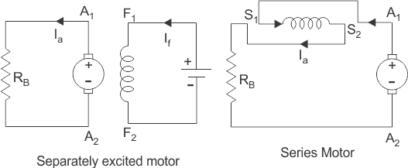When braking is required to occur quickly the resistance (RB) is considered to be of some sections. As the braking occurs and the speed of the motor falls, the resistance are cut out one by one section to maintain the light average torque. 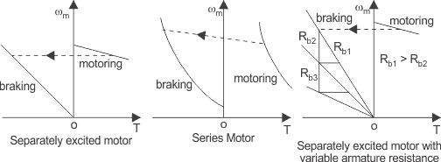Plugging is a type of braking where the supply voltage is reserved when the need of braking arises. A resistance is also introduced in the circuit while braking takes place. When the direction of the supply voltage is reserved, then the armature current also reserves forcing the back enf to a very high value and hence braking the motor. For series motor only armature is reversed for plugging. The diagram of separately excited and series excited motors are shown in the figure.** 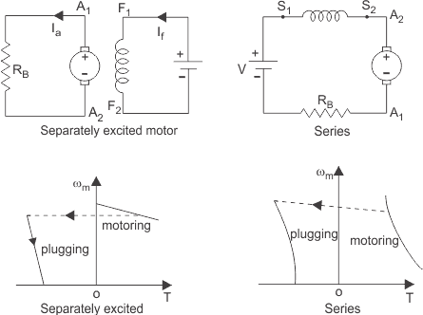

#### Speed Control of DC Motor Drives

**The main application of electric drives can be said as the need of braking of DC motors . We know the equation to describe the speed of a rotating DC motor drives is as https://www.electrical4u.com/equations/dcmd-1.gifNow, according to this equation, the speed of a motor can be controlled by the following methods**

1. **Armature voltage control**
2. **Field flux control**
3. **Armature resistance control**

**Among all of these, armature voltage control is preferred because of high efficiency and good speed regulation and good transient response. But the only disadvantage of this method is that it can only operate under the rated speed, because the armature voltage cannot be allowed to exceed rated value. The speed torque curve for armature voltage control is shown below. 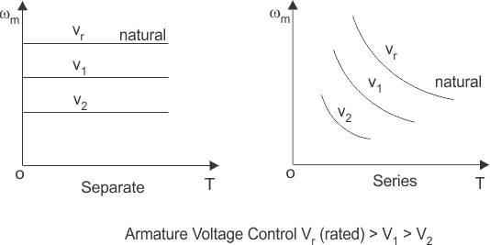When speed control is required above the rated speed, field flux control is used. Normally in ordinary machines, the maximum speed can be allowed up to twice of the rated speed and for specially designed machines this can be allowed up to six times of the rated speed. The torque speed characteristics for field flux control are shown in the figure below. 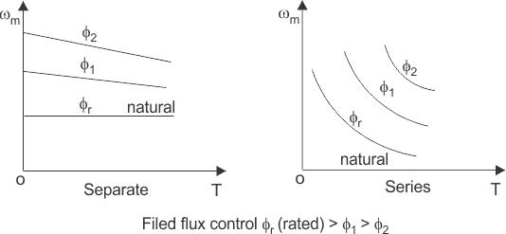How the armature voltage control and field flux control is made to operate below and above the rated speed is shown in the figure below. 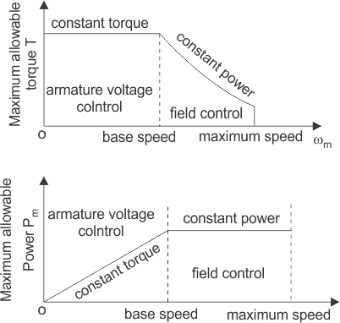Now, finally coming to resistance control method. Here speed is varied by wasting power in an external** [**resistor**](https://www.electrical4u.com/types-of-resistor-carbon-composition-and-wire-wound-resistor/) **that is connected in series with the armature. This method is not used very much because it is an inefficient method of controlling speed and it is only used in the places where the speed control time forms only a fraction of the total running time, such as traction. The speed torque curve of DC motor drives is given below.** 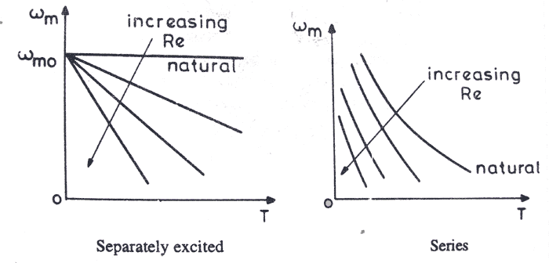

**Dual converter –four quadrant operation of DC motor:**

**Dual converter, the name itself says two converters. It is really an electronic converter or circuit which comprises of two converters. One will perform as rectifier and the other will perform as inverter. Therefore, we can say that double processes will occur at a moment. Here, two full converters are arranged in anti-parallel pattern and linked to the same dc load. These converters can provide four quadrant operations. The basic circuit diagram is shown below.**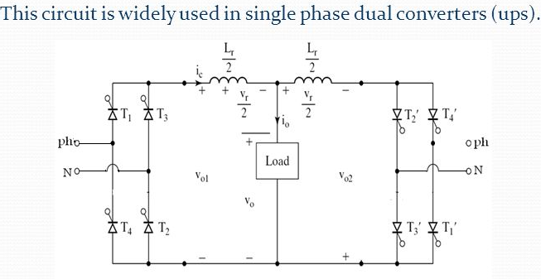

## odes of Operation of Dual Converter

**There are two functional modes: Non-circulating current mode and circulating mode.**

### Non Circulating Current Mode

* **One converter will perform at a time. So there is no circulating current between the converters.**
* **During the converter 1 operation, firing angle (α1) will be 0<α1< 90o; Vdc and Idc are positive.**
* **During the converter 2 operation, firing angle (α2) will be 0<α2< 90o; Vdc and Idc are negative.**

### Circulating Current Mode

* **Two converters will be in the ON condition at the same time. So circulating current is present.**
* **The firing angles are adjusted such that firing angle of converter 1 (α1) + firing angle of converter 2 (α2) = 180o.**
* **Converter 1 performs as a controlled rectifier when firing angle be 0<α1< 90o and Converter 2 performs as an inverter when the firing angle be 90o<α2< 180o. In this condition, Vdc and Idc are positive.**
* **Converter 1 performs as an inverter when firing angle be 90o<α1< 180o and Converter 2 performs as a controlled rectifier when the firing angle be 0<α2< 90o In this condition, Vdc and Idc are negative.**

1-phase fully controlled separately excited dc motor drive:

This adjustable speed drive is similar to the single-phase, half-wave controlled rectifier. As an example, this rectifier is presented to control a separately excited DC motor. The single-phase, full-wave controlled rectifier consists of four thyristors. The increase in thyristors provides for better control compared to the half-wave controlled rectifier. The obvious disadvantage of the full-wave rectifier is the increase in price because of the increase in the number of thyristor. Figure 3.4 shows a separately excited DC motor controlled by a single-phase, full-wave controlled rectifier.  
There are three different modes of operation for the single-phase, full-wave controlled rectifier. The first is discontinuous conduction mode (DCM). In DCM, the current Ia reaches zero and stays at zero for a certain period of time. The next mode is continuous conduction mode (CCM). In CCM, Ia does not reach zero at any point during the period. The finial mode of operation is critically discontinuous  
[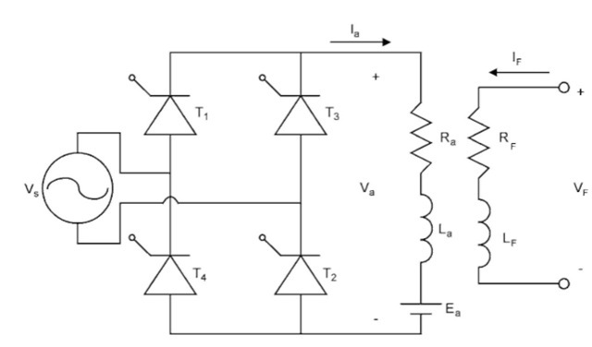](http://lh5.ggpht.com/_X6JnoL0U4BY/S1fxvKwNHbI/AAAAAAAAHQc/GVA3LId6bpg/s1600-h/tmpBC5_thumb13.jpg)  
**FIGURE Single-phase, full-wave, controlled rectifier.**  
conduction mode (CDCM). In CDCM, the current Ia reaches zero and then immediately starts to increase.  
Unlike the half-wave rectifier, the full-wave rectifier has the ability to manipulate the current when Vs is negative. There are three modes in DCM. The first mode is when from time t = 0 until a. Mode one is shown in Fig. 3.5. In mode one, there is no current in the armature; this results in a Va equal to the back emf Ea.  
Mode two occurs when the source voltage Vs is positive. Mode two is shown in Fig. 3.6. In mode two, T and T2 are conducting and T3 and T4 are not conducting. Va is equal to the source voltage Vs.  
The finial mode is mode three. Mode three is shown in Fig. 3.7. This mode is the opposite of mode two. In mode three, T3 and T4 are conducting and T and T2 are not conducting. This makes the voltage Va equal to the negative of the source voltage Vs.  
Figure 3.8 shows the waveforms of the rectifier in DCM. As seen in Fig. 3.8, the conducting angle occurs twice per period, once when the source voltage Vs is positive and again when the source  
[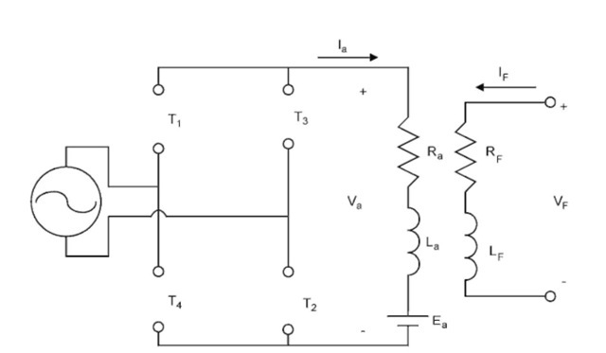](http://lh6.ggpht.com/_X6JnoL0U4BY/S1fxwxqvfyI/AAAAAAAAHQk/iUkMvbgbM8o/s1600-h/tmpBC6_thumb13.jpg)  
**FIGURE Mode one of DCM.**  
[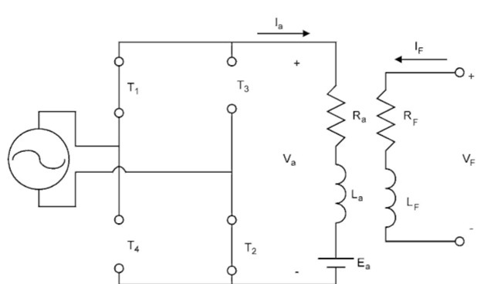](http://lh4.ggpht.com/_X6JnoL0U4BY/S1fxyMUolRI/AAAAAAAAHQs/bDCElayLVG0/s1600-h/tmpBC7_thumb13.jpg)  
**FIGURE Mode two of DCM.**  
[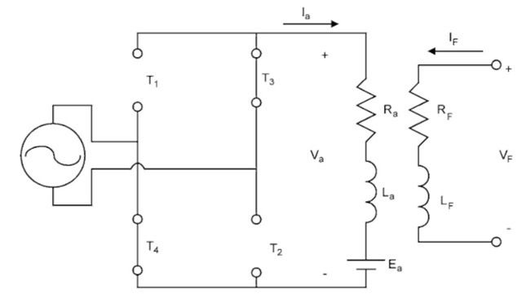](http://lh4.ggpht.com/_X6JnoL0U4BY/S1fxzzERyfI/AAAAAAAAHQ0/IhYo0fwhafY/s1600-h/tmpBC8_thumb13.jpg)  
**FIGURE 3.7 Mode three of DCM.**  
[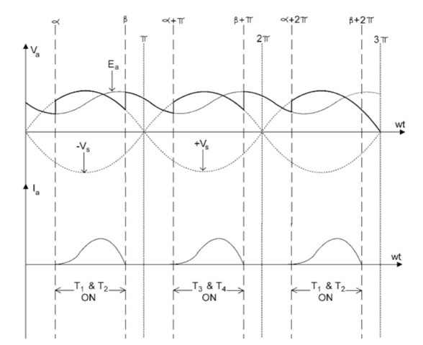](http://lh5.ggpht.com/_X6JnoL0U4BY/S1fx7x3a0BI/AAAAAAAAHQ8/Gqf7wiIO4sY/s1600-h/tmpBC9_thumb13.jpg)  
**FIGURE 3.8 Waveforms of a single-phase, full-wave controlled rectifier in DCM.**  
voltage is negative. In addition, in mode one, the voltage Va is equal to the back EMF Ea until a.  
Continuous conduction mode is similar to DCM, but in CCM mode one does not exist. Figure shows the circuit operating in CCM. CCM occurs when Va is large compared to Ea. Notice that Va is never equal to Ea.

